**12.R-2R LADDER DAC**

**12.1 OBJECTIVES**

1. Design a D to A Convertor with a resolution of 0.3125V using R-2R network. Assume the logic 1 to be 5V and logic 0 to be 0V.
2. Design a D to A Convertor with a resolution of 0.3125V using binary weighted resistors. Assume the logic 1 to be 5V and logic 0 to be 0V.

1. **HARDWARE REQUIRED**

|  |  |  |  |
| --- | --- | --- | --- |
| **S.No** | **Equipment/Component name** | **Specifications/Value** | **Quantity** |
| 1 | IC 741 | Refer data sheet in appendix | 1 |
| 3 | Resistors | 4K Ω  2K Ω  1K Ω | 1  7  4 |
| 5 | Dual Regulated power supply | (0 -30V), 1A | 1 |
| 5 | Regulated power supply | (0 -5V), 1A | 1 |
| 6 | Multimeter |  | 1 |

1. **THEORY**

In electronics, a digital-to- analog converter (DAC or D-to-A) is a device for converting a digital (usually binary) code to an analog signal (current, voltage or electric charge). Digital-to-analog converters are the interface between the abstract digital world and the analog real life. An analog-to-digital converter (abbreviated ADC, A/D or A to D) is an electronic circuit that converts continuous signals to discrete digital numbers. Most of the real world physical quantities such as voltage, current, temperature, pressure and time are available in analog form. Even though an analog signal represent a real physical parameter with accuracy, it is difficult to process, store or transmit the analog signal without introducing considerable error because of the superimposition of noise as in the case of amplitude modulation. Therefore, for processing, transmission and storage purposes, it is often convenient to express these variable in digital form. It gives better accuracy and reduces noise.

D/A conversion is an important interface process for converting digital signals to analog (linear) signals. An example is a voice signal that is digitized for storage processing, or transmission and must be changed back into an approximation of the original audio signal in order to drive a speaker.

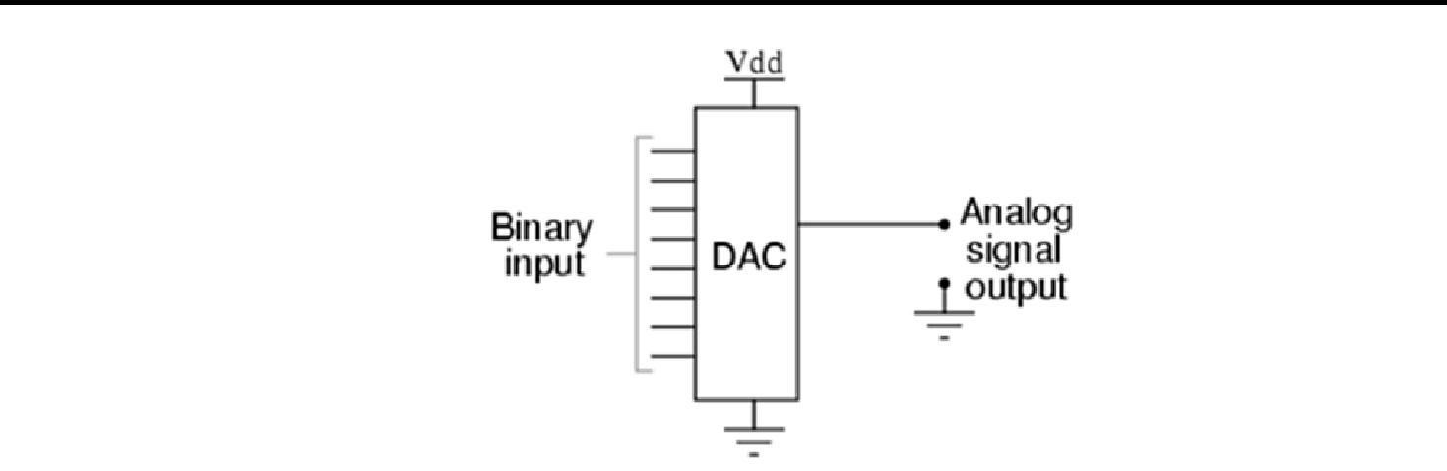

Figure-1: A basic DAC

**D/A Conversion fundamentals**

The DAC fundamentally converts finite-precision numbers (usually fixed-point binary numbers) into a physical quantity, usually an electrical voltage. Normally the output voltage is a linear function of the input number.

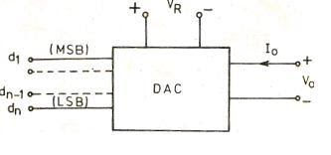

Figure-2: Block Schematic of a basic DAC

Figure-2 shows the basic configuration for digital-to-analog (D/A) conversion. The input is an n-bit binary word D and is combined with a reference voltage V*R* to give an analog output signal. The output of a DAC can be either a voltage or current. For a voltage output DAC, the D/A converter is mathematically described as

Vo = K VFS (d12-1+ d22-2+….+dn2-n)

Where, Vo =output voltage

VFS= full scale output voltage

K=scaling factor usually adjusted to unity

d1 d*2*... dn=n-bit binary fractional word with the decimal point located at the left d1 = most significant bit (MSB) with a weight of VFS / 2

dn=least significant bit (ISB) with a weight of VFs / 2n

Since the input to the D/A converter has a finite number of digital combinations, the resulting analog output also has a limited number of possible values (unlike pure analog signals, which may have an infinite number of values). The greater the number of possible values, the closer the analog output will be to the ideal value. The number of possible levels is determined by the number of lines or bits in the digital number. More specifically, the number of states is computed as 2N where N is the number of bits in the digital number. For example, an 8-bit D/A converter could be expected to produce 28, or 256, discrete output steps. If the full-scale range of the converter is 0 to 10 volts, then each step will be 10/256, or about 39 millivolts. If finer resolution is required, we need more bits in the digital number. Thus, a converter with 10-bit resolution would provide 210, or 1024, steps with each step being equivalent to 10/1024, or about 9.8 millivolts. Accuracy of a D/A converter describes the amount of error between the actual output of the converter and the theoretical output for a given input number. This rating inherently includes several other sources of error.

A certain amount of time is required for the output of a D/A converter to be correct once a particular digital number has been applied at the input. Two major factors cause this delay. First, it takes time for the changes to pass through the converter circuitry; this is called propagation time. Second, the output of the D/A converter has a maximum rate of change called slew rate, which is identical to the slew rate problems discussed with reference to op amps. The delays caused by slew rate limiting and propagation time are collectively referred to as settling time--the total time required for the analog output to stabilize after a new digital number has been applied to the input.

The overall operating range of a D/A converter can be shifted up or down from the optimum point. This DC offset is called offset error. In a somewhat similar manner, one end of the range can be correct but the other extreme too high or too low. This is called a gain error or scaling error.

As with A/D converters, we normally want a monotonic output. In other words, the output should increase whenever the input number increases. However, it is possible for a D/A converter to have a reduction in analog output at a particular point in its range, even though the digital input is increasing uniformly.

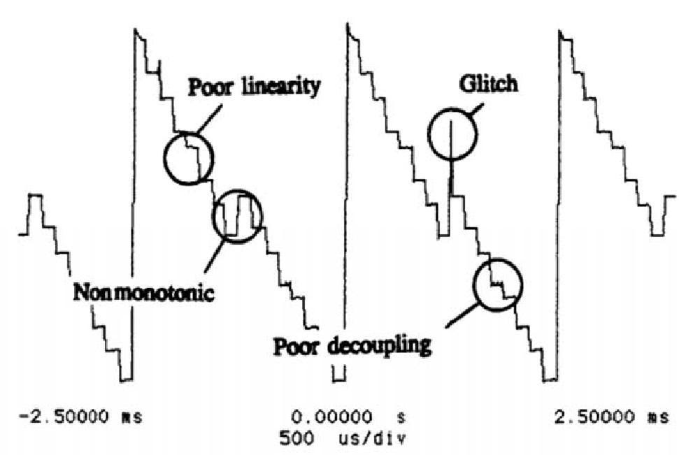

Figure-3: Oscilloscope display showing several imperfections in a low-quality D/A converter.

Figure-3 shows the performance of a low-quality D/A converter. Several of the potential problems described are present in the converted waveform. The input to the converter is a 4-bit down counter (e.g., 15, 14, 13... 2, 1, 0, 15), and the analog output should be 16 equally spaced, decreasing steps for each cycle, producing a reverse saw tooth waveform. If you examine the waveform carefully, you can see the 16 distinct output levels; however, the steps are not equal in amplitude (linearity problems)--the midpoint level actually increases instead of decreasing (non monotonic), and there are several glitches caused by switching transients.

**R-2R LADDER D/A CONVERTER**

One of the most popular methods for D/A conversion is shown in Figure-5. It is called an R2R ladder D/A converter, since the input network resembles the rungs on a ladder and the resistors in the input network are either equal (R) or have a 2:1 ratio (2R). One advantage of the R2R converter over the weighted converter previously discussed is immediately apparent; the resistors have a 2:1 ratio regardless of the number of bits being converted. This makes matching resistors much easier and even makes the use of integrated resistors practical.

An easy way to analyze the operation of the circuit is to Thevenize the input circuit for one or more digital input numbers. Once the input circuit has been simplified with the venin’s Theorem, you will be left with a simple inverting amplifier circuit whose input voltage is the Thevenin equivalent voltage and whose gain is determined by the ratio of feedback resistance to The venin equivalent input resistance. By performing several analyses with different input numbers, you will discover that the least significant input (b0) produces the least effect on output voltage, and the next input (bl) has twice as much effect on output voltage. Similarly, bit b2 has twice the effect of b1, but only half the effect onoutput voltage of b3. These variable effects are identical to the relative weights of the digits in a binary number.

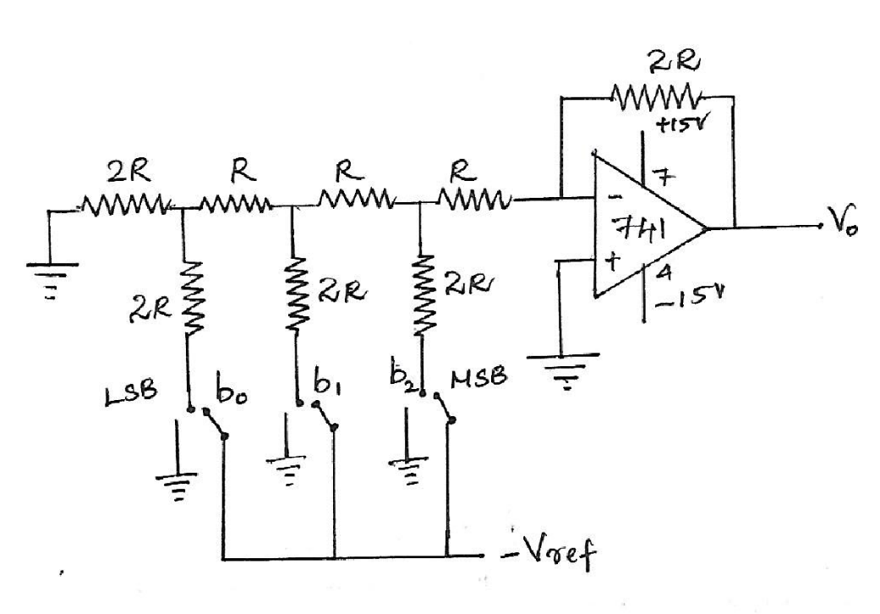

Figure-5: A 3-bit R2R ladder D/A converter utilizing a 741 op amp

**Calculations:** Output Voltage is given by

**Vo = - VR * (Rf / 2R) * (b2/2 + b1/4 + b0/8)**

where, VR = 5V, Rf = 2R, b2(MSB bit) and b0 (LSB bit)

**Design Constraints**

* Resistance should be use ±1 to ±5 tolerance
* Input voltage should be 5V for high and 0V for low.

**EXPERIMENT**

1. **R-2R LADDER DAC**
   1. Setup the circuit as shown in Figure-5. Select the approximate value of R and 2R
   2. Set the approximate value of R and 2R.
   3. Reference voltage VR is set as 5V
   4. Find the output voltage Vo for different combinations of digital binary inputs from 000 to 111.
   5. Compare the calculated values with observed values and plot DAC characteristics

**(b)  Experimental data and observations**

|  |  |  |  |  |
| --- | --- | --- | --- | --- |
| **R-2R LADDER DAC** | | | | |
| b2 | b1 | b0 | Vo ( observed) | Vo ( Calculated) |
| 0 | 0 | 0 |  |  |
| 0 | 0 | 1 |  |  |
| 0 | 1 | 0 |  |  |
| 0 | 1 | 1 |  |  |
| 1 | 0 | 0 |  |  |
| 1 | 0 | 1 |  |  |
| 1 | 0 | 1 |  |  |
| 1 | 1 | 0 |  |  |
| 1 | 1 | 1 |  |  |

**PRE LAB QUESTIONS**

1. Classify DACs on the basis of their output.
2. How many resistors are required in a 12-bit weighted-resistor DAC?
3. How many levels are possible in a 2-bit DAC? What is its resolution if the output voltage range is 0 to 3 V?
4. A 5-bit D/A converter is available. Assume that ‘00000’ corresponds to an output of +10 V and that the D/A converter is connected for -0.1V per increment. What output voltage will be produced for ‘11111’?

5. What is the resolution of a 0–5 V 6-bit digital-to-analog converter (DAC) ?

**POST LAB QUESTIONS**

1. Determine the output voltage of the DAC in Figure-7(a). The sequence of four-digit binary codes represented by the waveforms in Figure-7(b) are applied to the inputs. A high level is a binary l, and low level is a binary 0. The least significant binary digit is D0.

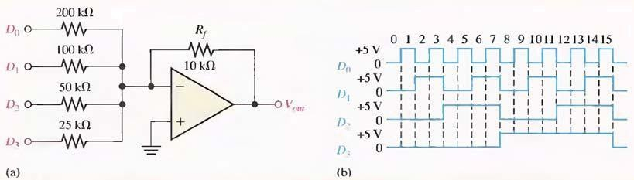  
  
 Figure-7

1. The R-2R ladder DAC shown in Figure-8 below consists of 10K & 20KΩ resistors, VREF = 2V and R1 = 10KΩ. Determine the values required for RF such that VFS = 10V.

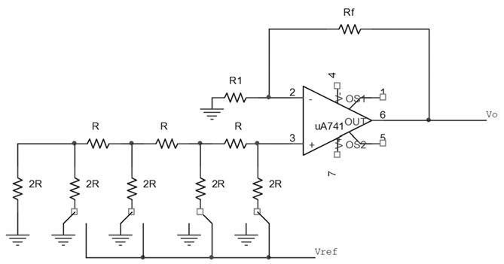

  Figure-8

R-2R Ladder DAC

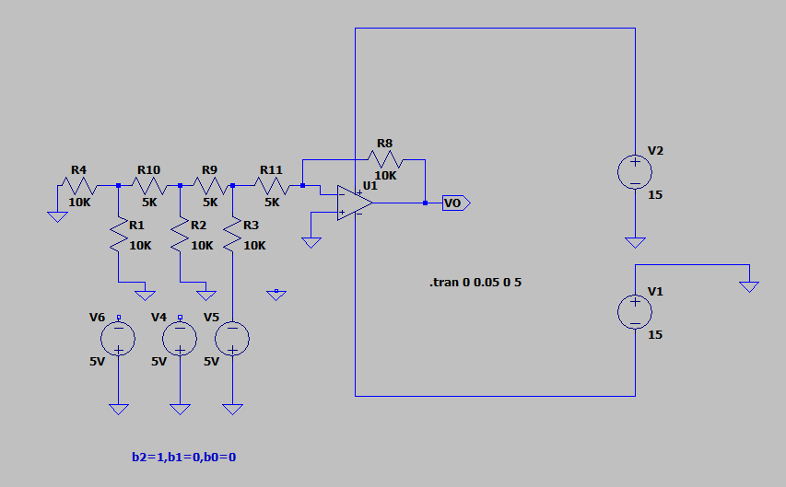

Graph for b2=1, b1=0, b0=0

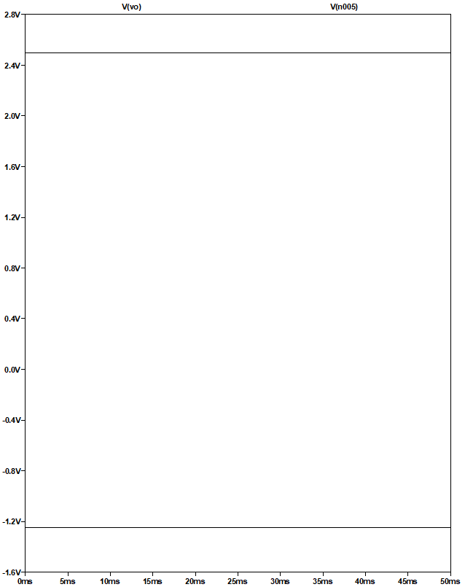

Similarly perform all the inputs as in below table and note down the values

Vo ( Calculated) **= - VR * (Rf / 2R) * ( b2/2 + b1/4 + b0/8 )**

where, VR = 5V , Rf = 2R , b2(MSB bit ) and b0 (LSB bit )

                       = -(-5)*(10K/10K)*(1/2)    For   b2=1, b1=0, b0=0

                       = 2.5V

Similarly perform all the inputs as in below table and note down the values

|  |  |  |  |  |
| --- | --- | --- | --- | --- |
| **R-2R LADDER DAC** | | | | |
| b2 | b1 | b0 | Vo ( observed) | Vo ( Calculated) |
| 0 | 0 | 0 |  |  |
| 0 | 0 | 1 |  |  |
| 0 | 1 | 0 |  |  |
| 0 | 1 | 1 |  |  |
| 1 | 0 | 0 | 2.5V | 2.5V |
| 1 | 0 | 1 |  |  |
| 1 | 0 | 1 |  |  |
| 1 | 1 | 0 |  |  |
| 1 | 1 | 1 |  |  |

3. What is the value of resistor required in weighted resistor DAC if LSB resistor value is 12KΩ for 4 bit DAC?

4. A 4-bit R/2R digital-to-analog (DAC) converter has a reference of 5 volts. What is the analog output for the input code 0101

5. What is the major advantage of the R/2R ladder digital-to-analog (DAC), as compared to a binary-weighted digital-to-analog DAC converter?

**Result:**